# Best Management Practices to Build Soil Health - Pasture

Name:________________________________________

Congratulations! You just inherited your grandparent’s farm in southwest Iowa. It is 400 acres of pasture land that has historically been used to raise beef cattle and sheep. See the map of the property below. The red line indicates the property boundaries. The blue lines indicate flowing water like streams and rivers. Other features like pastures, trees, and houses should be somewhat distinguishable.

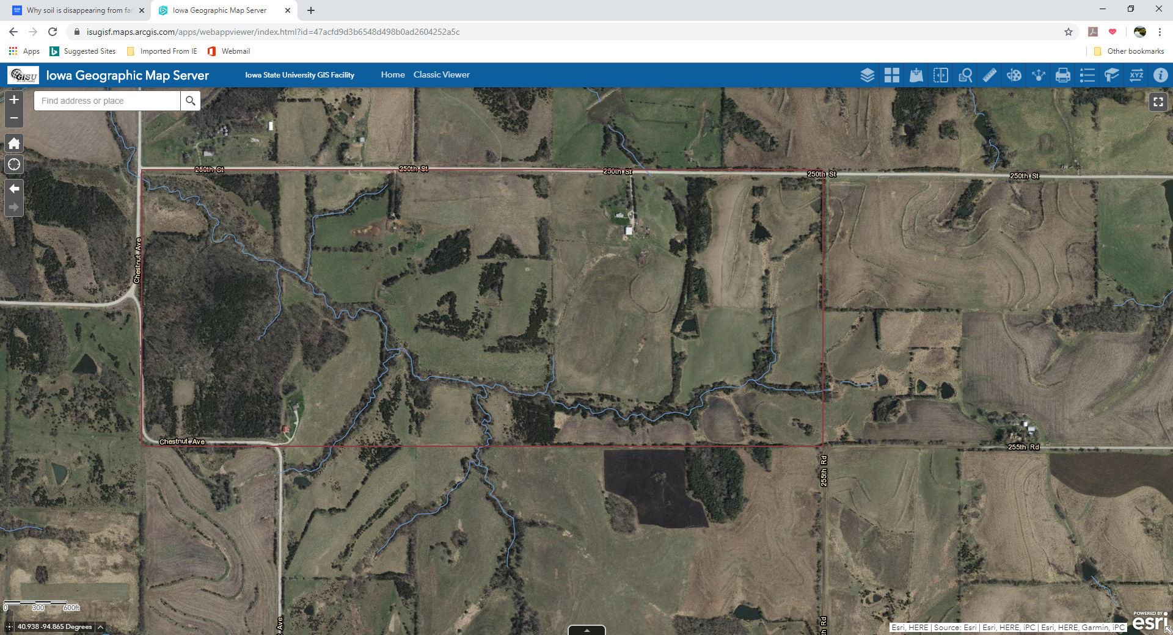

Over the past several years, the plant community has started to decline. You want to improve the soil health and plant community so that you can eventually increase the stocking rate. As the new manager, you are conscious about climate change and you know that improving soil health can help capture carbon.

Challenge: Design a system for utilizing the land for grazing cattle and/or sheep.

1. Use the map to determine where fences should be.
2. Ensure that animals always have access to water. If no stream access is available, indicate where a water source like a stock tank might be installed.
3. Identify the soil health best management practices you will implement of your farm to help increase soil health. Explain why you chose that practice and how you will implement it.
4. Be prepared to present your plan with the class.